Membership Application Form
Please fill out the required information and submit your completed application form to info@mirarco.org. Our representatives will contact you for further details, membership agreements, and payment processing.

CONTACT INFORMATION
Organization Name:
Contact Person:
Email:
Phone:
Mailing Address:

MEMBERSHIP LEVEL
Please select your preferred membership level using an “X” in the designated box. Details about membership levels can be found in the table below and linked in the level titles.
Membership Level | Ideal for | “X”
Superuser Membership | - Organizations that commercialize, adopt, and / or implement biotechnologies  - Entities working on large or multiple projects  - Projects that require a pilot / demonstration site and / or access to specialized equipment and expertise
Key User Membership | - Organizations advancing research in biotechnology for mining  - Entities working on smaller projects  - Projects that require a pilot / demonstration site and / or access to specialized equipment and expertise
Ecosystem User Membership | - Organizations that want to be part of a unique, pilot-scale facility  - Mining stakeholders who want package flexibility  - Those who need to connect with other members and keep abreast of activities and advancements in this space

MEMBERSHIP TERM START DATE
Please specify the start date for your membership and the desired term (1, 2, or 3 years).
- [Select Date]
- [Select Term]

MEMBERSHIP AGREEMENT
Upon completion of this form, the MIRARCO Mining Innovation team will be in touch to discuss your interest and the Membership Agreement. By becoming a member, you agree to abide by the terms and conditions of MIRARCO Mining Innovation. This includes the commitment to support and engage in the activities related to your chosen membership level.

PAYMENT INFORMATION
Once your application is approved, we will send you an invoice for the membership fees.

ADDITIONAL COMMENTS/REQUESTS
Please use this space to include any additional comments or special requests regarding your membership.

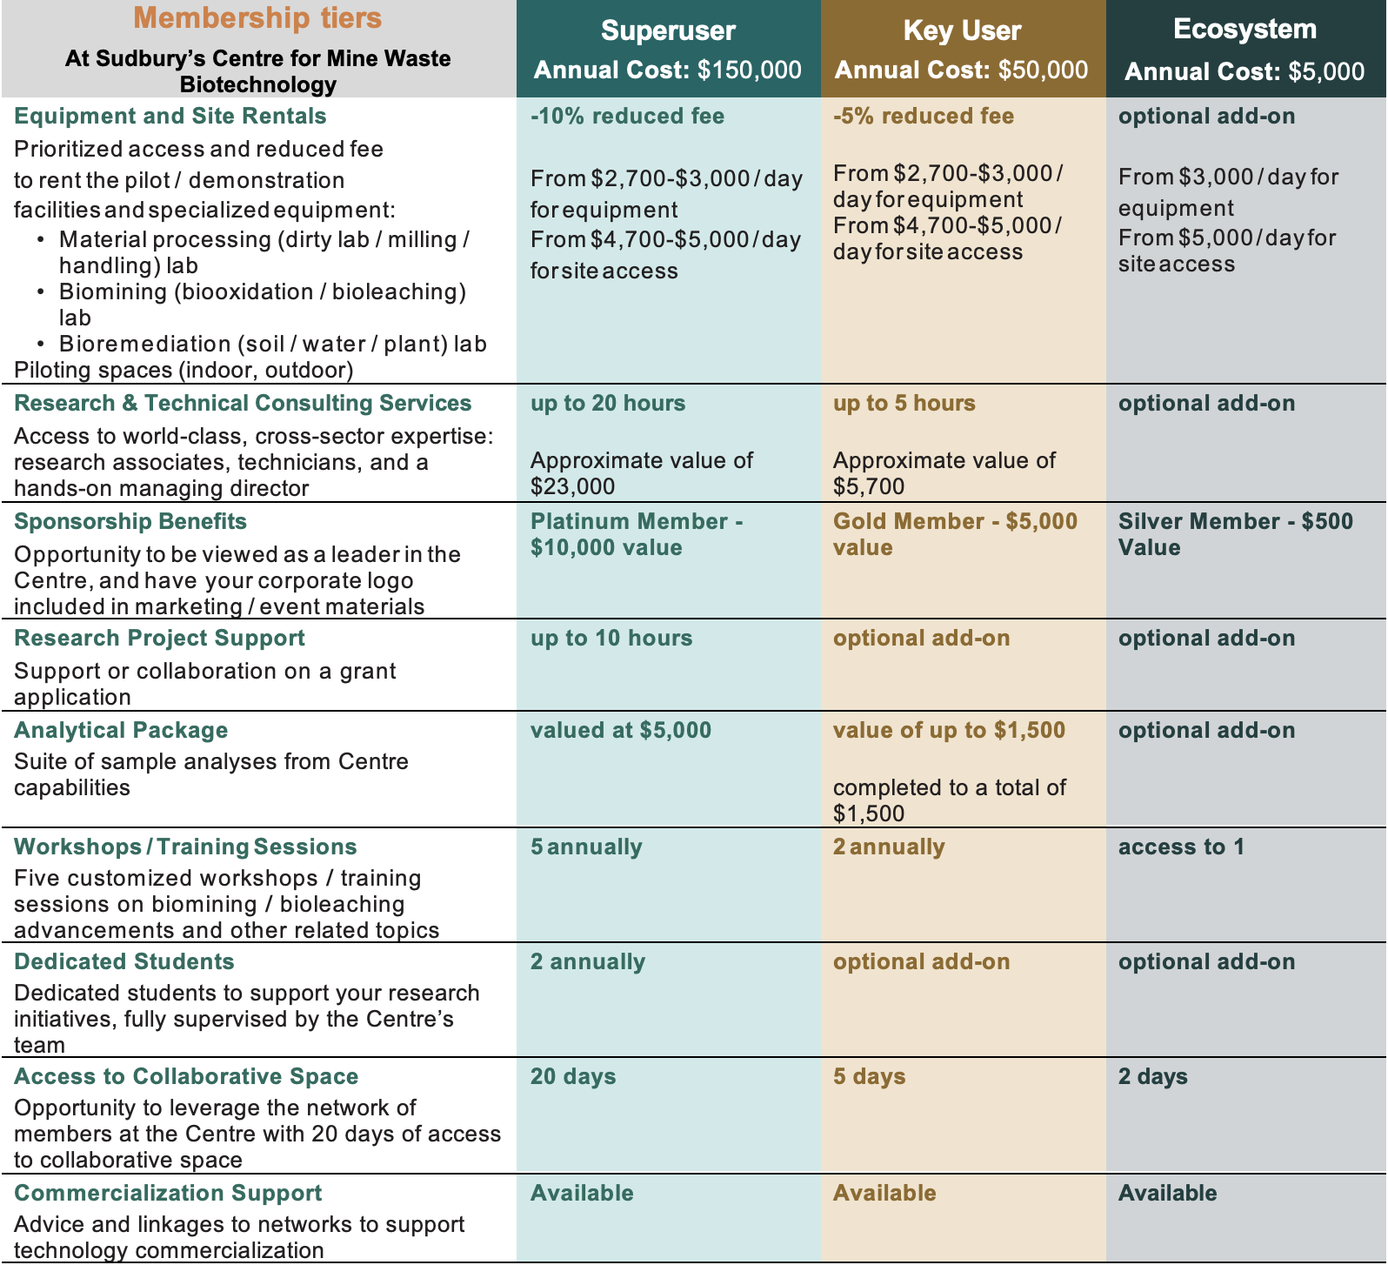
MEMBERSHIP DETAILS
Please fill out the required information and submit your completed application form to info@mirarco.org. Our representatives will contact you for further details, membership agreements, and payment processing.

